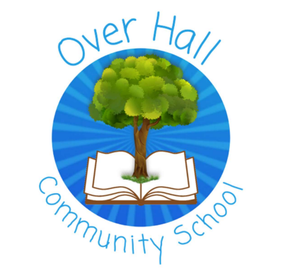
Art Long Term Plan 2023 - 2024
 | Autumn | Spring | Summer
Reception | DRAWING  Create closed shapes with continuous lines and begin to use these shapes to represent objects.  Draw with increasing complexity and detail, such as representing a face with a circle and including details.  PAINTING  PUPPETS  Use drawing to represent ideas like movement or loud noises.  Show different emotions in their drawings and paintings (happiness, sadness, feat, etc.). | PRINTING  3D MODELS  Explore colour and colour-mixing.  Show different emotions in their drawings  (happiness, sadness, fear, etc.).  WEAVING  Explore, use and refine a variety of artistic effects to express their ideas and feelings. | COLLAGE  SCULPTURE  Return to and build on their previous learning, refining ideas and developing their ability to represent them.  CLAY  MAKE SOMETHING MOVE  Create collaboratively sharing ideas, resources and skills.
Year 1 | DIGITAL MEDIA  INCLDUING DRAWING  Recreate images of our local area/town using Rodger Hargreaves’ style of work.  Create a Mr Men character for themselves /their house /school and trees and layer them onto their background. | COLLAGE  INCLDUING DRAWING  Recreate their own (Victorian) landscape scenes, inspired by Lowry.  Create images from a variety of media. | TEXTILES  Create a space scene.  Investigate tone by drawing light/dark lines, light/dark shapes.  Investigate textures by describing, naming, rubbing, copying.
Year 2 | PAINTING  INCLUDING DRAWING  Create own painting landscape of the River Weaver in the style of Monet. | 3D SCULPTURE  Produce clay sculptures inspired by Bog Baby.  PRINTING  Geometric Shape Art, inspired by Yayoi Kusama.  Create own printing blocks.  Link to Aboriginal artwork (Geog. Study from Spring Term) | DT focus – Double Art focus last term.
Year 3 | DT focus – Double Art focus next term. | PAINTING  INCLUDING DRAWING  Stone Age to Iron Age Artwork.  Cave drawings on a background.  COLLAGE  The great paper caper criminal mugshots/ wanted posters, inspired by Laura Shabazz. | DIGITAL MEDIA  Refugees or deserts artwork.  Research and collate images and add artwork, text, etc.  Inspired by Banksy.
Year 4 | PRINTING  INCLUDING DRAWING  Create a Roman Shield using printing techniques.  Create printing blocks using a relief or impressed method.  Overlay printing with 2 colours.  Inspired by Linda Germain. | TEXTILES  Environmental artwork, inspired by Andy Goldsworthy.  Use a variety of techniques (printing, stitching, dyeing and weaving). | 3D SCULPTURE  INCLUDING DRAWING  Create clay coil pots, inspired by Grayson Perry.
Year 5 | DIGITAL MEDIA  Digital landscapes.  Inspired by David Hockney. | 3D SCULPTURE  Ancient Mayan Art  Worry dolls | TEXTILES  Malala and Pakistan  Inspired by Malala Yousafzai
Year 6 | COLLAGE  INCLUDING DRAWING  Still life and Guernica | PRINTING  James Green | PAINTING  INCLUDING DRAWING  The faces of Winsford.  Frida Kahlo

