Over Hall Community School



Primary Attendance and Absence Policy

|  |  |
| --- | --- |
| Date policy last reviewed: |  |

|  |  |  |  |
| --- | --- | --- | --- |
| Signed by: | | | |
|  | Headteacher | Date: |  |
|  | Chair of governors | Date: |  |

**Introduction and Aim**

Over Hall Community Schoolrecognises the importance of good attendance and the impact it has on children’s progress, attainment, enjoyment of learning and relationships within school. Good attendance helps a child to realise their potential and ensure they are motivated, confident and enjoy a diverse range of curricular opportunities and experiences. Our school policy and prospectus promote good attendance, which is recognised and rewarded as an achievement. The school monitors attendance and ensures quick and early intervention if a problem is identified. We recognise that whole school preventative and proactive approaches are key to promoting children wellbeing and attendance. A child must attend school every day that they are required to do so unless an exceptional circumstance applies.

Our policy is accessible to leaders, staff, pupils, and parents, and is published on our school website. It will be sent to Parents with any initial information when pupils join the school and reminded of it at the beginning of each school year and when it is updated. As the barriers to attendance evolve quickly, the policy should be reviewed and updated as necessary. In doing so, we will seek the views of pupils and parents. The Attendance & Punctuality Policy is based on the premise of equal opportunities for all.

1. **Legislation**

Regular and punctual attendance at school is a legal requirement. Regular attendance is essential to enable children to maximise their educational attainment, opportunities and further development.

* Section 7 of the Education Act 1996 states that “The parent of every child of compulsory school age shall cause him/her to receive efficient full-time education either by regular attendance at school or otherwise”.
* Section 444 (1) of the Education Act 1996 states that “if a child of compulsory school age who is a registered pupil at a school fails to attend regularly at the school his parent is guilty of an offence”.
* Section 576 Education Act 1996 - Meaning of “parent”

For the purposes of Education Law, the definition of a ‘parent’ and who is responsible for ensuring regular attendance to school is:

* all biological parents, whether they are married or not
* any person who, although not a biological parent, has parental responsibility for a child or young person - this could be an adoptive parent, a step-parent, guardian or other relative
* any person who, although not a biological parent and does not have parental responsibility, has care of a child or young person. This could be one parent, both parents and/or carer/s.

1. **Registers**

Registers provide the daily record of attendance of all pupils. They are legal documents and the register may be required in a court of law, for example as evidence in prosecutions for non-attendance in school.

‘Education (Pupil Registration) (England) Regulations 2006’ (section 6)

Schools must take the attendance register at the start of the first session of each school day, morning (a.m.) and once during the second session, afternoon (p.m.).

On each occasion they must record whether every pupil is:

• Present

• Attending an approved educational activity

• Absent

• Unable to attend due to exceptional circumstances.

The school should follow up any absences to:

• Ascertain the reason

• Ensure the proper safeguarding action is taken

• Identify whether the absence is approved or not; and,

• Identify the correct code to use before entering it on to the school’s electronic register, or management information system as a priority and returned to the school office in a timely manner. This is used to download data to the School Census.

* Consider early identification, assessment, intervention and support processes that may need to be implemented.

The register should be marked using the codes as advised by the Department for Education (DfE) ‘Working together to improve School Attendance Guidance’ (for maintained schools, academies, independent schools and local authorities) <https://assets.publishing.service.gov.uk/government/uploads/system/uploads/attachment_data/file/1073616/Working_together_to_improve_school_attendance.pdf> (*See appendix 3.)*

1. **Procedure**

Children are expected to attend school regularly, unless there is good reason for absence.

There are two types of absence:

* Authorised (where the school approves a pupil absence)
* Unauthorised (where school will not approve the absence)

The school has a duty to safeguard all its pupils. If a child is absent, the parents/carers should inform the school on the **first day of absence** and each following day of absence, stating the reason.

Parents/Carers are expected to ring school on the first day of absence and every day thereafter and with an expected date of return.

The name and contact details of the senior leader responsible for the strategic approach to attendance in school is *Mrs Anna Hopley*

The school office will make contact with home when a child is absent, and the parent/carer has not notified the school of the absence. If no contact can be achieved or the reason for absence is not accepted the absence will be unauthorised. School will continue to call and will send text messages, if no response a home visit will take place.

1. **What can parents/carers do to help and working in partnership with Parents/ Carers**

Let the school know straight away why your child is absent. Home/school communication is

extremely important in supporting your child to achieve and feel settled in school. Try to make any dental/GP/optician’s appointments outside of school time

It is pertinent that school and parents / carers work together with a shared plan and outcomes when supporting a child / young person’s attendance and wellbeing. If despite persistent attempts to work with parents, there continues to be a lack of engagement, then legal procedures may be followed to secure engagement and school attendance.

As a school we recognise that building respectful relationships with families and working in collaboration is essential to ensuring the best outcomes for children / young people. We require all parents to actively support the work of the school, including promoting attendance and engagement. We are committed to ensuring that systems and processes are in place with regards to promoting attendance and would encourage parents to make contact if they have concerns about their child.

We will provide parents / carers with information about Emotionally Based School Non-attendance to discuss needs and strategies to support their child, as appropriate (see EBSN Parent Leaflet).

1. **Absence Monitoring**

School robustly monitor and analyse attendance data to promptly identify and address possible concerns and allow for early interventions to support the child/family’s underlying needs. This will include –

* Weekly attendance code analysis
* Specific cohort and group monitoring – particularly for vulnerable groups i.e. children with a social worker
* Monitoring of lesson attendance across all subjects
* ‘Welcome back’ meeting for all pupils that have been absent for 5 days – to check wellbeing and ensure there are no ongoing needs that will impact on attendance
* The school’s strategy for using data to target attendance improvement efforts to the pupils or pupil cohorts who need it most.
* The school’s strategy for reducing persistent and severe absence, including how access to wider support services will be provided to remove the barriers to attendance and when support will be formalised in conjunction with the local authority.

1. **Early Identification and Intervention: assess, plan, do and review**

Every pupil has a right to a full-time education and Over Hall Community Schoolsets high attendance expectations for all pupils. Over Hall Community Schoolwill consider the individual needs of pupils and their families who have specific barriers to attendance and will consider our obligations under the Equality Act 2010 and the UN Convention on the Rights of the Child.

For any child / child person who is absent from school it is essential to fully understand the reasons for this so that targeted, evidence-based interventions and support can be put into place. All staff have a part to play in promoting attendance. We recognise the importance of ensuring that key members of staff from across the school, including Form Tutors, attendance, pastoral and SEND staff work in collaboration to consider and identify the holistic needs of the child/young person and to overcome barriers to attendance. In accordance with the principles of early intervention, a graduated approach of assess, plan, do and review will be followed utilising a arrange of school-based resources, evidence-based interventions and seeking advice and support from external services at an appropriate stage, when needed.

Appropriate assessments will be important to help understand the underlying reasons that may be contributing to attendance difficulties. This may be an assessment that focuses on the individual child’s needs such as an SDQ, SEND assessments and wellbeing assessments or may include the holistic needs of the family, such as a TAF assessment. Assessments will include the views of the child/young person as well as parents/carers, and identify strengths (what is working well) and needs (what is working less well).

Assessments undertaken may identify that a child/young person is experiencing underlying emotional based needs that are contributing to non-attendance. Cheshire West and Chester Council has developed guidance for schools - Emotionally Based School Non-attendance: Good practice guidance for schools (revised November 2021). This is a whole school framework with a graduated approach to support the early identification and intervention of children/young people who may struggle to cope in school/attend school.

Information from assessments will inform a SMART action plan with focussed targets developed in partnership with families, and other services as appropriate. For example, Early Help and Prevention and Social Care may have a part to play in the delivery of support and intervention to promote engagement and attendance. SMART plans should be personalised to effectively meet a child / young person’s needs and improve attendance and wellbeing outcomes.

Regular reviews of support and attendance plans are essential to monitor the impact of interventions and to adjust these accordingly. If, despite targeted support and intervention, attendance and wellbeing concerns persist, we may seek further advice and support from external services including mental health services and specialist teaching and education services.

1. **Medical Absence**

Absence due to illness should be reported to the school by phone 01606663650 on the first day of absence and any subsequent days. School will contact parents during the first day if no satisfactory reason for absence has been received. The school will ask about the child’s symptoms in order to record their absence accurately.

In the majority of cases, a parent’s notification that their child is ill can be accepted without question or concern. Schools should not routinely request that parents provide medical evidence to support illness. Schools are advised not to request medical evidence unnecessarily as it places additional pressure on health professionals.

Only where the school has a **genuine and reasonable doubt about the authenticity** of the illness should medical evidence be requested to support the absence. In instances of **long-term or repeated absences for the same reason**, however, seeking medical evidence may be appropriate to assist in assessing whether the child requires additional support to help them to attend more regularly, and whether the illness is likely to prevent the child from attending for extended periods. If a parent proactively seeks out a note from a GP, it does not imply a need for absence unless this is explicit in their letter.

If a medical absence is likely to be ongoing or long term, then we will offer support in accordance with the school’s policies and statutory guidance relating to Children with health needs. <https://www.gov.uk/government/publications/supporting-pupils-at-school-with-medical-conditions--3>.

As a school we need to plan how children can access Education and how and when the child will return to school. In accordance with the Equality Act 2010 the school must also demonstrate that reasonable adjustments are made to meet child’s Educational Needs.

For children who have a medical condition and cannot attend school, the school will refer to the Cheshire West and Chester Council’s Medical Needs Team. <https://www.cheshirewestandchester.gov.uk/documents/education-and-learning/medical-needs-service/medical-needs-policy-latest.pdf>

Their policy states that referrals must come directly from the child’s school and must be supported by medical evidence from one of the following health professionals:

* consultant paediatrician or adolescent psychiatrist
* consultant child psychiatrist
* hospital consultant

Supporting evidence from a General Practitioner alone cannot be accepted.

1. **Lateness and Punctuality**

At Over Hall Community School,we will apply a robust day to day process to track and follow up on absence and poor punctuality. We will ensure registers are completed accurately and on time, twice per day, in accordance with the timings set out below. This will indicate which pupils are absent from or are late for school. The following timings set out the expectations for all of our pupils at Over Hall Community School.

* Our gates open at 8.30 and classroom doors open at 8.40am
* We expect all pupils to be in their classroom by 8.50am ready for registration.
* Registers are open for marking at 8.50am. If your child is in class at this time, they will be marked as present.
* Registers close at 9.10am. If your child arrives at school after 8.50am but before 9.10am, they will be marked as late and will receive the **L code**.
* Our gates and classroom doors will close at 8.50am which means your child will need to enter the school by the main entrance and the parent/carer will need to sign them in
* If your child arrives at school after the registers have closed at 9.10am, they will be marked as late and will receive the **U code**. This is an unauthorised absence for that session.
* Afternoon registers will be taken at 1pm
* Afternoon register will close at 1.10pm

In accordance with the ‘Education (Pupil Registration) (England) Regulations 2006’, if your child arrives after the registers close, they will receive a mark, code U, that shows them to be on site, but this will **not** count as a present mark and it will mean they have an unauthorised absence. This may mean that you could face the possibility of a Fixed Penalty Notice or other legal action if the problem persists.

Children who are consistently late for school are disrupting not only their own education, but also that of other children. Where persistent lateness gives cause for concern, you will be invited to a meeting to resolve the issues. If there is no improvement following this meeting, further action will be taken which may include referral to external agencies.

You may approach the school at any time for support and advice if you are having difficulty getting your child to school on time or maintaining regular attendance.

1. **Unauthorised Absence and Fixed Penalty Notice**

An absence may be coded as ‘unauthorised’ if:

* + 1. no reason for absence has been given
    2. medical evidence is not received when requested
    3. a request for a leave of absence has been unauthorised
    4. a pupil arrives at school after registration has closed at 9.10am

Parents/carers should be aware that Over Hall Community Schoolmay contact the Local Authority if a pupil has 10 or more unauthorised absences in the current term with a view to issuing a Fixed Penalty Notice or other legal action. The Fixed Penalty Notice is issued individually to each parent/carer who fails to ensure their child’s regular attendance at school. The Penalty is £60 per parent/carer per child if paid within 21 days rising to £120 if paid within 28 days. Non-payment of the Fixed Penalty Notice may result in prosecution in the Magistrates court *(see appendix 1).*

1. **Promoting and Incentivising Attendance (Rewards and Incentives)**

At Over Hall Community Schoolrewards, incentives and competitions play an important part when working to improve attendance. **The most effective schools consistently promote the benefits of good attendance.** Rewards and incentives should be devised with the children’s and families views at the heart. This will mean that our incentives and rewards are purposeful and meaningful. At Over Hall Community School, we have dojo points for being in school on time, improved attendance post cards, Classes over 98% win a golden ticket towards a class treat, 100% attendance each term and for a full year, the School Council will play an important part in this to ensure that we improve attendance in the most effective way. **Schools that have good attendance recognise that it is not a discrete piece of work but rather it is an integral part of the school’s ethos and culture.**

**At Over Hall Community School,****we understand that some pupils find it harder than others to attend school**. Therefore, it is important that attendance is recognised, celebrated and held in high regard, no matter how small the improvements might be. Improved attendance or improved punctuality should be recognised and praised, not just ‘perfect’ attendance. Every child has the right to feel they can achieve and be successful, so any reward/incentive system must be inclusive of those with children with additional needs. It is important that pupils see the attendance incentives and competitions as a team effort and not to blame individuals. At <insert school name> pupils will be taught about the positive link between attendance and high achievement through assemblies and dedicated PSHE sessions.

Attendance information should be readily available for both children and parents. At Over Hall Community School,we will share attendance information in the form of notice board, website, assemblies, newsletters and information being sent home. Barriers affecting attendance in our school will be explored, taking both the children and parents views into account, so that every staff member is clear about how they can help to improve attendance and/or punctuality. This will be reflected in our rewards and incentives and time will be dedicated to such barriers in order to try to remove them. At Over Hall Community School, we will recognise and celebrate attendance on a weekly basis allowing all families the opportunity to achieve and feel successful - a new week, a new start!

Consequences might be used alongside our rewards and incentives.

We are proud to be a Trauma Informed school, and as such, all pupils will be welcomed back to school by their class teacher, class Teaching assistant or a member of SLT and reasons for their lateness or absence will be explored sensitively with barriers established and the necessary support provided. At Over Hall Community School, we recognise that some pupils will require their own individual reward systems.

* 1. **Application for Exceptional Circumstances**

In September 2013, amendments to the Education (Pupil Registration) (England) Regulations 2006, make it clear that Head Teachers may not grant any Leave of Absence (holiday) during term time unless there are ‘**exceptional circumstances**’

The Head Teacher and the Trustees will determine what constitutes an exceptional

circumstance on an individual basis. If parents/carers need to request Exceptional Leave of Absence, they must complete an ‘Exceptional Leave of Absence’ form available from the school office. It should be noted that if any application is declined and absence occurs of a consecutive 5 or more unauthorised days, then school may apply to the Local Authority for a Fixed Penalty Notice to be issued to each parent/carer.

The following will not be deemed to be exceptional circumstances:

* Family holiday
* Availability of less expensive holiday
* Availability of holiday accommodation
* Parent/carer’s working commitments
* Holiday pre-booked by another family member

A child’s absence during term time seriously disrupts their continuity of learning. Not only do they miss the teaching on the days they are away but are less prepared for the lessons building on that teaching when they return to school. There is a consequent risk of under achievement, which we must seek to avoid.

The Trustees are responsible for ensuring any attendance issues are dealt with in line with school policy.

**Religious Observance**

We recognise that some pupils may need to participate in days of religious observance.

Where a day of religious observance.

* falls during school time and
* has been exclusively set apart for religious observance by the religious body to which the pupil belongs

We ask that parents/carers notify Over Hall Community School, in writing in advance where absence is required due to a religious observance.

1. **Enforced School Closure**

If Over Hall Community School, was forced to close for a period of time, we have the facility to operate an online virtual school. The expectation is children will still engage with ALL activities when work is set. Procedures for online learning will be sent to parents as and when required.

1. **Impact**

All pupils will achieve well by developing knowledge and skills on their journey through school. Due to robust monitoring of attendance, all pupils, including vulnerable children and children with special educational needs and disabilities (SEND), will have fair and equitable access to school in order to achieve the best possible outcomes. Pupils will leave Over Hall Community School, ready for a successful transition to secondary education*.*

# The table below sets out the attendance targets and at what stage parents/carers will be contacted about their child’s attendance.

See appendix 2 for further breakdown of missed sessions.

**At less than 90% a stage 4 letter would be issued, and consideration given to legal action.**

# Appendix 1

**Cheshire West & Chester**

**Code of Conduct for Education Fixed Penalty Notice (Unauthorised Leave of Absence & Irregular**

**Attendance)**

1. A Fixed Penalty Notice (FPN) can only be issued in cases of unauthorised absence.

2. A maximum of two FPNs may be issued in an academic year and these FPNs may be issued against each parent/carer of a child. Once two FPNs have been issued, should there be further unauthorised absences, the Local Authority are able to move to prosecution immediately.

3. A FPN may be issued per parent per child.

4. Penalty Notices may be considered appropriate if:

* Unauthorised absences of at least 10 consecutive school sessions (five school days).
* Sessions either side of a weekend or school holiday will be counted as consecutive school days.
* For poorly attending learners, at least 10 sessions (five school days) lost due to unauthorised absence during a school term. These do not need to be consecutive.
* For poorly attending learners, persistent late arrive at school in a term. Persistent means at least 10 sessions of late arrival.
* The presence of an excluded child in a public place in the child’s first five days of exclusion.

6. The school must notify parents of the Attendance Policy and clearly state that parents may receive an FPN for an unauthorised leave of absence relating to holiday in term time.

7. Schools and the Education Welfare Services will take into account any exceptional circumstances when determining whether to issue an FPN.

# 

# Appendix 2

# What does ‘percentage attendance’ mean?

Parents/carers should be advised that from September 2015 the Government have categorised those pupils who have attendance of 90% and below as ‘Persistent Absence’ pupils (P.A.). RSA will be specifically targeting this cohort of pupils, in an effort to improve their attendance in the future. The table below shows the learning time lost against percentage attendance figures.

|  |  |  |  |  |
| --- | --- | --- | --- | --- |
| Attendance during one school year | **Equivalent**  **Days** | **Equivalent**  **Sessions** | **Equivalent**  **Weeks** | **Equivalent Lessons**  **Missed** |
| 95% | 9 Days | 18 Sessions | 1.4 Weeks | 45 Lessons |
| 90% | 19 Days | 38 Sessions | 3.4 Weeks | 95 Lessons |
| 85% | 29 Days | 58 Sessions | 5.4 Weeks | 145 Lessons |
| 80% | 36 Days | 72 Sessions | 7.1 Weeks | 180 Lessons |
| 75% | 48 Days | 96 Sessions | 9.3 Weeks | 240 Lessons |

# 

# Appendix 3

**Absence Codes:** According to the DfE guidance the following codes are used on the register.

|  |  |  |  |
| --- | --- | --- | --- |
| **Code I** | Illness | | Schools can request medical evidence from parents/carers if they feel the authenticity of an illness is in doubt. |
| **Code M** | Medical or dental appointments | | Parents/Carers are encouraged to arrange appointments out of school hours but the school will authorise if confirmation of the appointment is provided. |
| **Code C** | Other circumstances | | This code will be used for any authorised non-medical reasons for a child’s absence from school, i.e. – family funeral. |
| **Code D** | Dual Registered | | This code will be used if a pupil is registered at two schools. |
| **Code J** | Interview | | This code will be used when it has been agreed that the pupil can miss school to attend an interview or entrance exam |
| **Code P** | Approved sporting activity | | This code will be used in times of approved sporting activities in school times, i.e. – training sessions, trials and sporting events. |
| **Code R** | Religious Observation | | This code is used to cover major religious festivals during term-time. The school will only authorise one day absence for religious events. |
| **Code V** | Educational visits and trips | | |
| **Code W** | Work Experience | | |
| **Code G** | Family holiday not authorised by the school or in excess of agreed period | | |
| **Code L** | Late arrival before the register is closed | Schools should actively discourage late arrival and be alert to patterns of late arrival. All schools are expected to set out in their attendance policy the length of time the register will be open, after which a pupil will be marked as absent. This should be the same for every session and depending on the structure of the school day not longer than either 30 minutes after the session begins, or the length of the form time or first lesson in which registration takes place. | |
| **Code U** | Arrived in school after registration closed | Where a pupil has arrived late after the register has closed and the school is not satisfied that the reason for lateness is an authorised absence. Schools should actively discourage late arrival, be alert to patterns of late arrival and seek an explanation from the parent. | |
| **Code N** | Reason for absence not yet provided | | |
| **Code O** | Absent from school without authorisation | | |
| **Code X** | Not required to be in school (not compulsory school age) | | |

**Guidance for schools – Attendance case working. (School only)**

These stages should be followed once a pupil has reached 10 sessions of unauthorised absence and the school is considering the Education Welfare Service’s involvement as current strategies are not improving attendance.

**Stage 1 (within 30 days)**

* Ensure usual attendance policy procedures are being followed
* Continue normal first day contact etc.
* Conduct investigative safeguarding home visits.
* Gather information from teaching and support staff regarding the pupil’s strengths and needs – this may include a round robin
* Meet with pupil to elicit their views about school (eg. what is working well / working less well)
* Develop a shared action plan in collaboration with parents / carers, pupils and key staff (informed by assessments and to address specific factors underlying non-attendance)
* Continue to follow assess, plan, do and review cycles focussed on targeted intervention and support – eg. Support and Attendance Plan
* Make an initial single assessment (simplified TAF assessment)
* Refer to other agencies as appropriate (e.g iART)

**If parent/carer does not engage with support offered**

* Arrange an Attendance Panel Meeting to discuss barriers to attendance, record the voice of the child and complete and ESO checklist
* Consider an irregular attendance FPN (10-26 sessions unauthorised)
* Consider a first warning letter for prosecution for more entrenched cases (26+ sessions)

**Stage 2 (within 60 days)**

* Continue with usual contact in line with attendance policy
* Conduct further home visits
* Discuss case with attendance lead in school
* Consider Attendance Planning Meeting if there is no improvement following the prosecution first warning letter
* Issue a final warning letter if no improvement following the Attendance Planning Meeting
* Consult with Education Welfare Officer to support in preparing witness statement and exhibits of evidence

**Stage 3 (within 90 days)**

* EWO will support in setting up Court File as follows:
* Statement of evidence S9
* Exhibits (labelled and numbered)
* Head teacher certificate
* Recent registration certificate

Please note, each section says WITHIN the time scale, so you don’t have to wait until 30 days have passed to take action.

**Emotionally Based School Non-attendance (EBSN)**

Emotionally Based School Non-attendance (EBSN) is a term used to describe the needs of CYP who struggle to attend school due to underlying emotional based needs, such as anxiety, unhappiness and despair. These CYP may be reluctant to leave home and can present high levels of distress in response to parents’ attempts to get them to school. This can result in prolonged absences from school.

EBSN is complex and multifaceted, requiring a holistic approach to assessment and intervention. Good practice guidance emphasises the importance of early identification and intervention to support the needs of CYP who may struggle to attend school, developing a SMART support plan, with timely review processes (CW&C, 2018).

The EBSN framework is embedded within the school’s Attendance Policy and we use many of the tools and resources to underpin our early identification of need and targeted support and intervention approach.

Schools can access EBSN training and Guidance (EBSN: Good Practice Guidance for Schools) via: [eCWIP for Education - Cheshire West Industry Professionals](https://www.ecwip.education/)

**Letter templates below:**

**Letter 1 - Attendance Concern**

**Letter 2 - Medical evidence letter**

**Letter 3 - Invite to Attendance Action Plan meeting**

**Letter 4 - Attendance Action Plan**

**Letter 5 - After failure to attend meeting**

**Letter 6 - First Warning Letter**

**Letter 7 - Final Warning Letter**

**Letter 1 - Attendance concern**

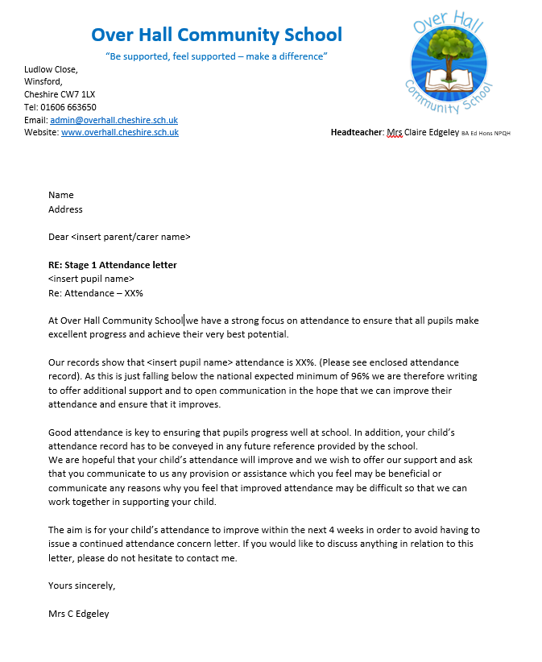

**Letter 2 - Medical evidence letter**

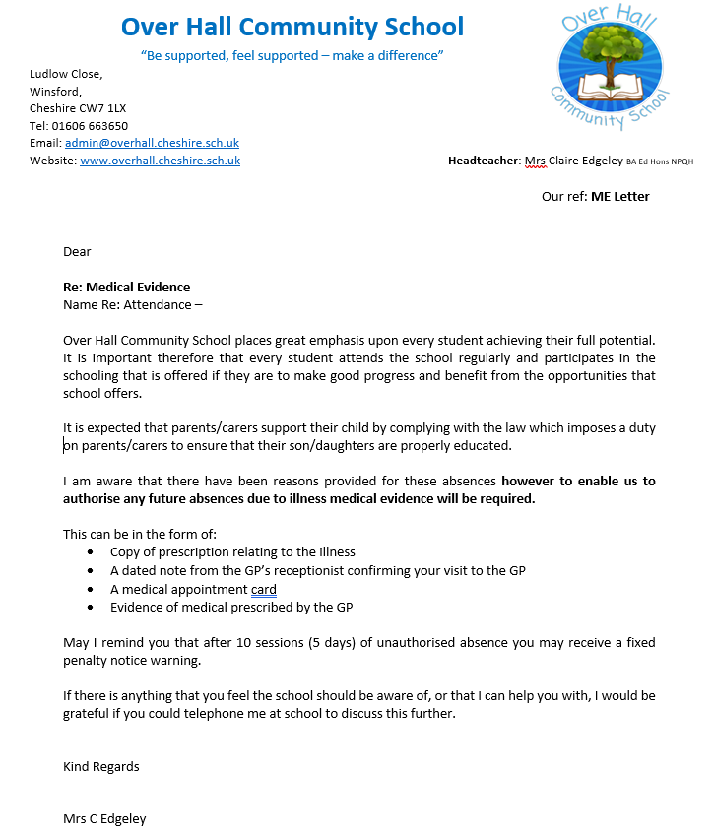

**Letter 3 - Invite to Attendance Action Plan meeting**

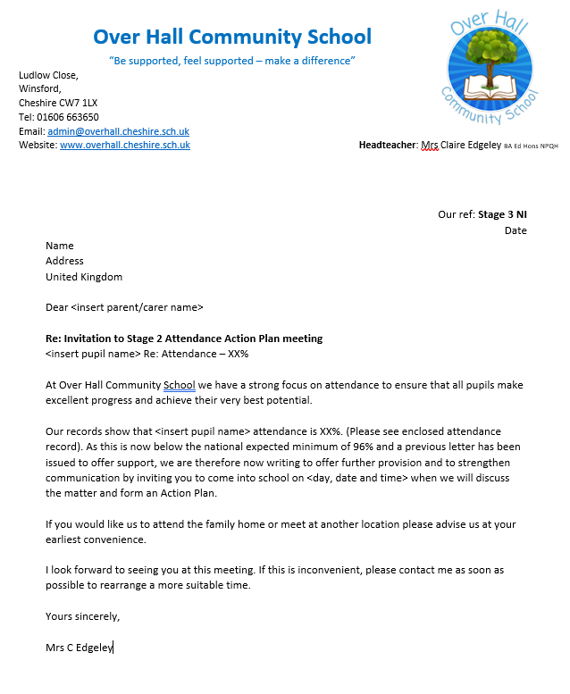

**Letter 4– Attendance Action Plan** 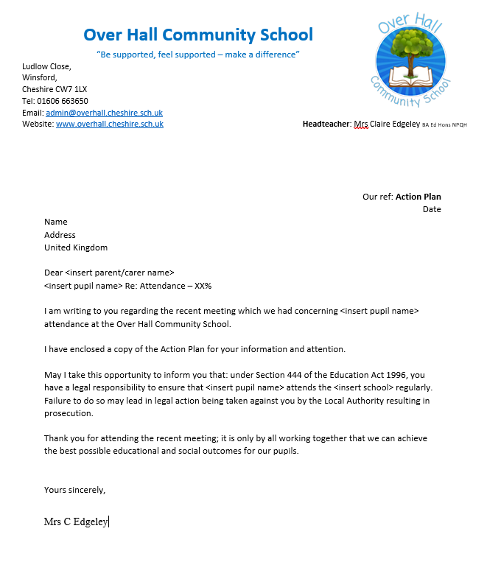

**Letter 5 - After failure to attend meeting**

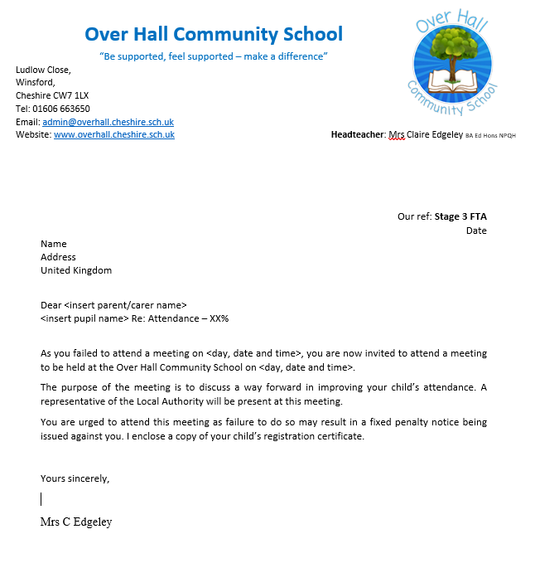

**Letter 6 - First Warning Letter**



**Letter 9 - Final Warning letter**

