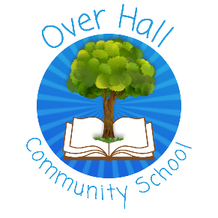
EYFS
Knowledge and Understanding of the World
What should I already know? |  | What will I know by the end of Spring
- That some places are different to Winsford – hotter or colder; near the sea or very hilly.  - People celebrate different events: birthdays, Christmas, New Year and Diwali.  - Have tasted or even made a pancake for Shrove Tuesday. |  | You will be able to:  - Describe how the landscape of our school has changed.  - Discuss how some foods are sour and some sweet.  - Talk about what happens to ingredients when they are cooked.  - Describe the stages of plant growth.

Vocabulary
To use | To hear
seed – what we put in the ground and grows into a plant. | germinate – when a seed starts to grow
leaf – grows on a plant or tree | stem – the main part of a plant that the leaves grow from
soil – what plants and trees grow in | pollinate – when bees help new seeds grow
flower – the colourful part that bees like | seasons – Spring, Summer, Autumn, Winter
Spring – the time of year when plants begin to grow and many animals have young | blossom – flowers on trees that we see in Spring
cooking – when food is heated | habitat – the place where animals live like a woodland or a pond
pancake – a type of food made with eggs and flour | Shrove Tuesday – also called Pancake Day; when Christians prepare for Lent
batter – the mixture made with eggs, flour and milk | ingredients – the different foods you mix together in a recipe

