Our Terrific 10 books for this half term:  - Tiny Little Rocket by David Fickling  - A Rocketful of Space Poems by John Foster  - The Lost Stars by Hannah Cumming  - Beegu by Alexis Deacon  - How To Catch A Star by Oliver Jeffers  - Laura’s Star by Klaus Baumgart  - The Fox and The Star by Coralie Bickford-Smith  - Whatever Next by Jill Murphy  - Owl Babies by Martin Waddell  - Goodnight Moon by Margaret Wise Brown  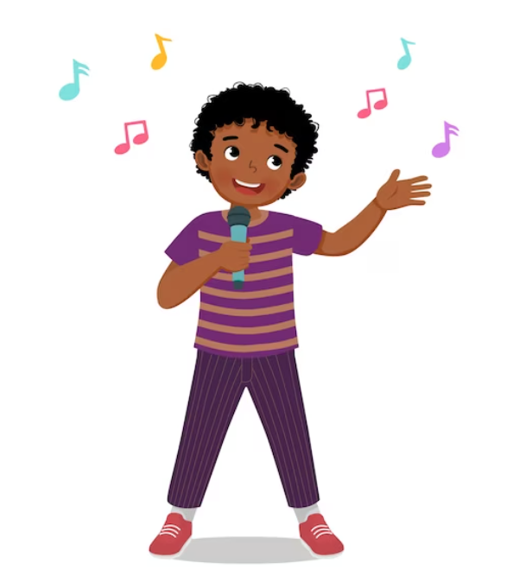  Our Super 6 for this half term:  - Hickory Dickory Dock  - I’m a little teapot  - Mary had a little lamb  - Moon Rocket  - 5 little men in a flyer saucer  - 5 Little Ducks | Expressive Arts and Design:  - 2Paint A Picture  - Paint Projects  - Jigsaws 2Pairs (Fine Motor planning)  - Hold a pencil effectively in preparation for fluent writing – using the tripod grip in almost all cases. Use a range of small tools, including scissors, paint brushes and cutlery. Begin to show accuracy and care when drawing.  Printing / 3D Models  - Explore colour and colourmixing.  - Show different emotions in their drawings – happiness, sadness, fear etc. | Understanding the World  Recognise some similarities and differences between life in this country and life in other countries.  Celebrations Along the Way  - RSPB’s Big School’s Birdwatch  - National Storytelling Week  - NSPCC Number Day  - Rosa Parks Day  - Children’s Mental Health Week  - Safer Internet Day  - Chinese New Year  - Pancake Day  - Valentine’s Day
Personal, Social and Emotional  Identify and moderate their own feelings socially and emotionally. Think about the perspectives of others.  One Decision Units:  - Green gets glasses  - Blue learns to share  - Orange moves house  - Purple the passenger  - Yellow wants to play with orange  - Rainbow feels angry  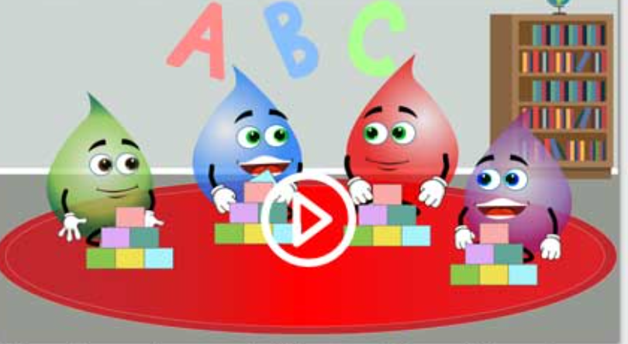  - Red’s nut allergy | Physical Development  Speed Agility Travel 1  Gymnastics 2  Revise and refine the fundamental movement skills they have already acquired:  - rolling - crawling - walking - jumping - running - hopping - skipping – climbing  Confidently and safely use a range of large and small apparatus indoors and outside, alone and in a group.  Develop overall body-strength, balance, coordination and agility.  One Decision – Mini yoga sessions | Communication and Language  - Use new vocabulary through the day.  - Articulate their ideas and thoughts.  - Describe events in some detail. Listen to and talk about stories to build familiarity and understanding.  - Listen to and talk about selected non-fiction to develop a deep familiarity with new knowledge and vocabulary
Glossary  - Connect - Bringing objects together  - Join -Objects become linked  - Build - Making something by putting parts or materials together  - Pulse/Beat/Metre  - Rhythm  - History – The study of past events  - Past – Gone by in time and no longer exsiting  - Present – Exsisting or occurring now  - Earth – The planet that we live on  - Art – A visual form of creative activity and imagination  - Picture – Something representing how an object looks  - Drag/Drop – Pick up and move something on the screen  - Cooking – when food is heated  - Pancake – a type of food made with eggs and flour  - Batter – the mixture made with eggs, flour and milk |  | Phonics  - Blend sounds into words, so that they can read short words made up of known letter-sound correspondences.  - Read some letter groups that each represent one sound and say sounds for them.  - Read simple phrases and sentences made up of words with known lettersound correspondences and a few common exception words.  Sounds we will be learning:  w,x,y,z, zz qu,ch,sh ,th,ng dge,ve  Helpful words:  you, they, all, are, her
Maths  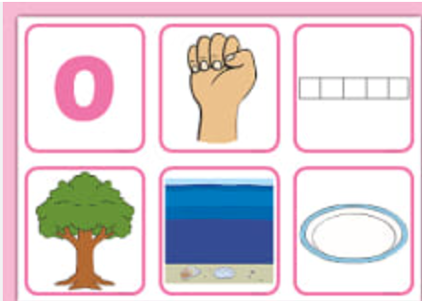  Introduce zero  Find 0 to 5  Subitise 0 to 5  Represent 0 to 5  1 more  1 less  Composition  Conceptual subitising to 5  Find 6, 7 and 8 Represent 6, 7 and 8  Composition of 6, 7 and 8  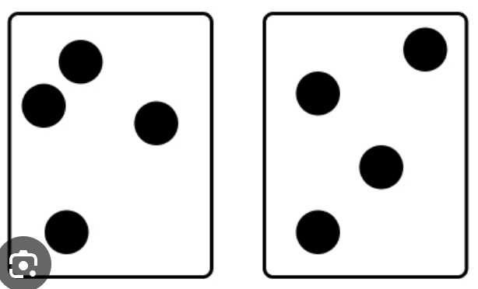  Make pairs-odd and even  Double to 8 (find a double)  Double to 8 (make a double)  Combine 2 groups Conceptual subitising  Compare mass  Find a balance  Explore capacity Compare capacity |  | 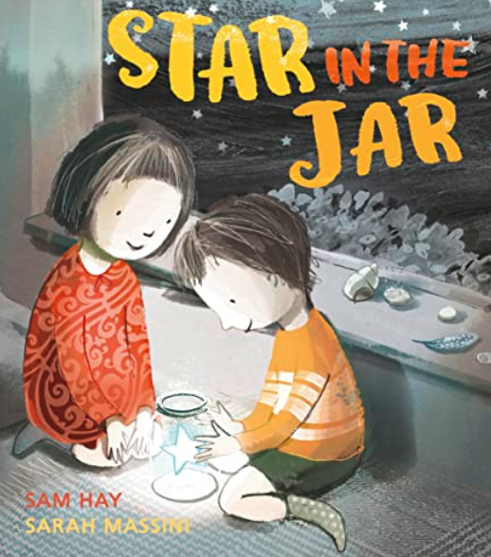  Writing outcomes:  Narrative: A Finding Story  Purpose: To tell and write a finding story  Information: Poster to find a lost star  Purpose: To inform (and describe)  Further writing and mark making opportunities  - Spell words by identifying the sounds and then writing the sounds with letters.  - Write short sentences with words with known letter sound letter correspondences.  - Re-read what they have written to check that it makes sense.

