Personal, Social and Emotional  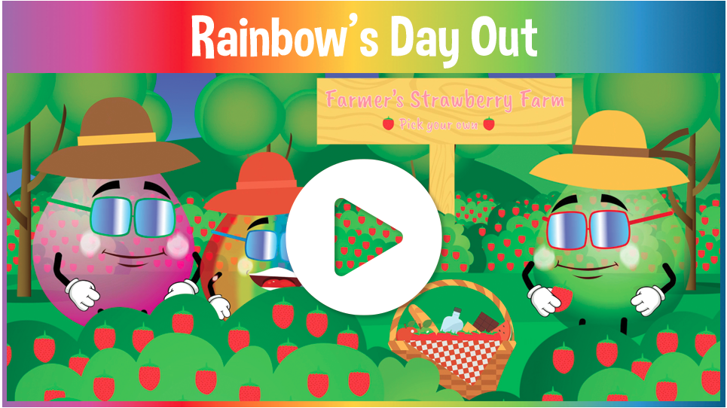  One Decision Units  -Orange brushes her teeth  -Green stays in hospital  -Purple’s Pet Bird Rainbow’s day out  -Pink feels sad  -Red visits the dentist  -Pink’s screen time  -Show an understanding of their own feelings  -Show understanding of others feelings (empathy)  -Regulate own behaviour Set and work towards simple goals  Control impulses through waiting when appropriate  -Give focused attention to adults  -Follow instructions involving several ideas or actions  -Be confident to try new activities  -Demonstrate independence Show resilience and perseverance  -Know right from wrong  -Explain the reasons for rules  - Try to follow the rules  -Managing personal needs and hygiene  -Understanding healthy food choices  -Understanding healthy living |  | Understanding the World  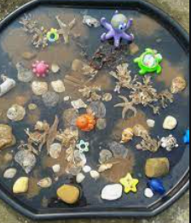  -Name and describe people who are familiar to them. Compare and contrast characters from stories, including figures from the past.  -Understand the effect of changing seasons on the natural world around them  - Seasons - Summer  - What is different about the season now.  - Materials for creating a rock pool.  - What creatures live at the beach?  - Talk about past and present in their lives. Discuss if they have ever been to the seaside, what do they remember?  - Know all children are different.
Physical Development  - Body Management 2 Speed Agility Travel 2  - Further develop and refine a range of ball skills including: throwing, catching, kicking, passing, batting, and aiming.  - Develop confidence, competence, precision and accuracy when engaging in activities that involve a ball. One Decision – Mini yoga sessions  - To hold scissors safely and correctly and cut out various materials. To paint using thinner brushes. To form letters using the correct letter formation and control the size of the letter, considering where they sit on the given line.  - Skills 2 Ride Pedals - Pedal and Glide. Zig Zags. Corner Explorer. Limbo. Children can pedal and glide for 10 metres. Ride in a zigzag for 20 metres. Corner to the left and right. Move my full body left, right, forwards and backwards on the bike.  - Handwriting  Wk 1/2 - v, s, r Wk 3/4 - f, x, z | Expressive Arts and Design:  Collage / Sculptures  Return to and build on their previous learning, refining ideas and developing their ability to represent them.  Expressive Arts and Design opportunities may include:  - different media.  - Make 3d hanging butterflies.  - Recycled plastic bottle fish  - paper plate fish/jellyfish/starfish  - Experiments with colour, design, texture, form and function  - Design own sea creature  - Make – wind chimes -Sounds of summer.  - Charanga- Our World | Communication and Language  -Articulate their ideas and thoughts in well-formed sentences. Use new vocabulary in different contexts.  -Ask questions to find out more and to check they understand what has been said to them.  -Use talk to help work out problems and organise thinking and actions.  -Explain how things work and why they might happen.  -Connect one idea or action to another using a range of connectives.  -Re-tell the story, once they have developed a deep familiarity with the text: some as exact repetition.  Super 6 (Songs, Nursery Rhymes and Poems)  -5 currant buns in a baker’s shop  -- 10 in a bed  - A rainbow of Feelings  - I went to the shop  -10 green bottles  -Miss Polly had a dolly

Maths  -Build numbers beyond 10 (10 -13)  -Continue patterns beyond 10 (10-13)  -Build numbers beyond 10 (14-20)  - Continue patterns beyond 10 (14-20)  -Verbal counting beyond 20  -Add more How many did I add?  -Take away How many did I take away?  -Select shapes for a purpose  -Rotate shapes  -Manipulate shapes  -Explain shape arrangements  -Compose shapes  - Decompose shapes  -Copy 2-D shape pictures  -Find 2-D shapes within 3-D shapes | 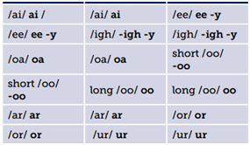  Phonics  -Read simple phrases and sentences made up of words with known letter-sound correspondences and a few exception words.  -Read a few common exception words matched to the school’s phonic programmes  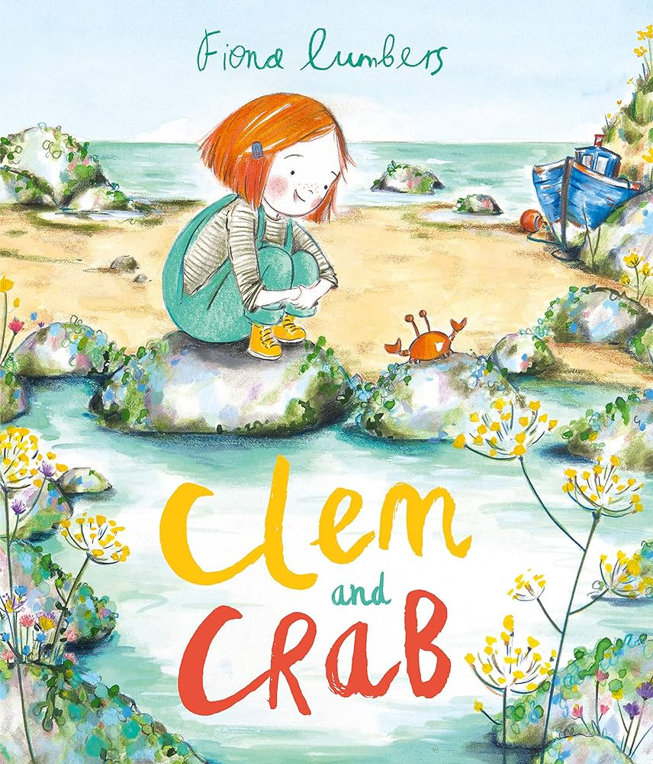  English  – To write a friendship story and a letter to inform  -Write short sentences with words with known sound-letter correspondences using a capital letter and full stop.  -Re-read what they have written to check that it makes sense.  Focus Texts to explore (Terrific 10)  -Seed To Plant by National Geographic Kids  -It Starts With A Seed by Laura Knowles  -Kate Who Tamed The Wind by Liz Garton Scanlon  -Oliver’s Vegetables by Vivian French  -Clean Up! By Nathan Bryon  -Lucy and Tom At The Seaside by Shirley Hughes  -One Is A Snails Ten Is A Crab by April Pulley Sayre  -My World, Your World by Melanie Walsh  -Under The Ocean by Anouck Boisrobert Kipper’s Beach  Glossary  Crab, rockpool, legs, claws, bucket, shells, plastic, paper, glass, metal, rubbish, beach, sea  Once upon a time, next, later that day

