Design and Technology

Spring Knowledge Organiser

Reception

**Clay**

|  |  |
| --- | --- |
| Key Vocabulary | Definition |
| Moulding | Turning it into something |
| Piercing | A mark made by something sharp |
| Clay | A type of material |

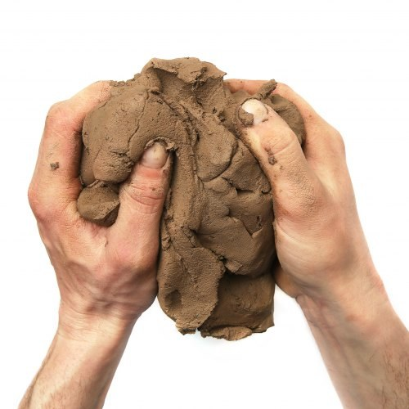

**Prior Knowledge**

I can create collaboratively, sharing ideas, resources and skills

I can use different techniques for joining materials, such as how to use paper clips, string, split pins and elastic bands

I can develop my small motor skills so that I can use a range of tools competently, safely and confidently

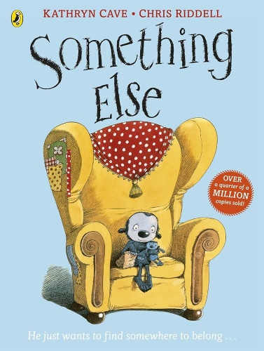

**What will I know by the end of the unit?**

I will make my own something else creature from clay.

I will explore adding marks and textures to my clay using tools such as pens, lollipops, forks etc

I will explore moving my clay though pounding, pushing, rolling, squeezing, poking, pinching and twisting.

**Scissor Skills**

* I will cuts square shape
* I will cuts complex shapes, such as figures.

