

**Mathematics Curriculum**

**Overview**

**2024-2026**

**EYFS**

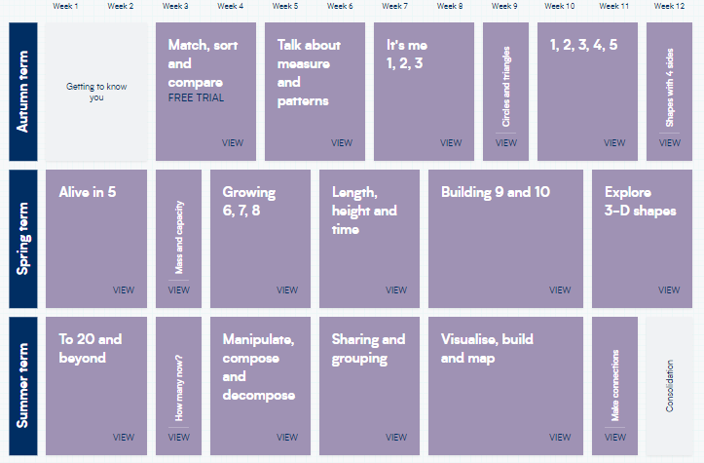

**YEAR ONE**

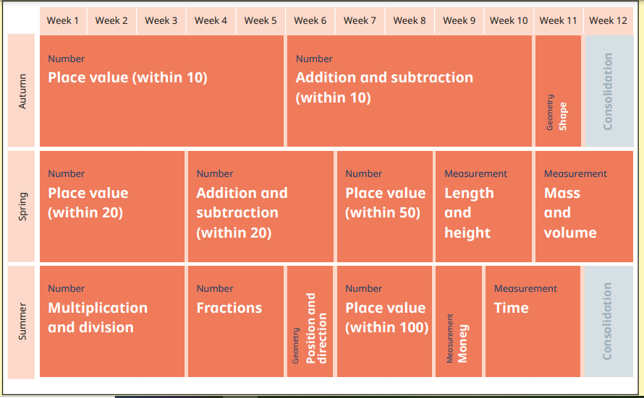

**YEAR TWO**

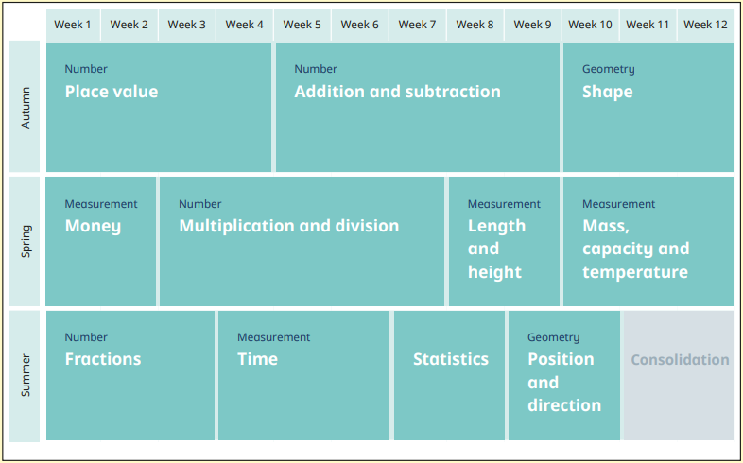

**YEAR THREE**

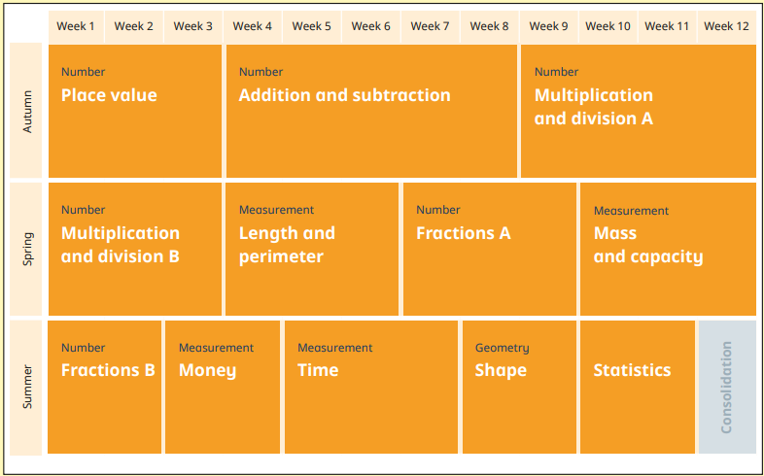

**YEAR FOUR**

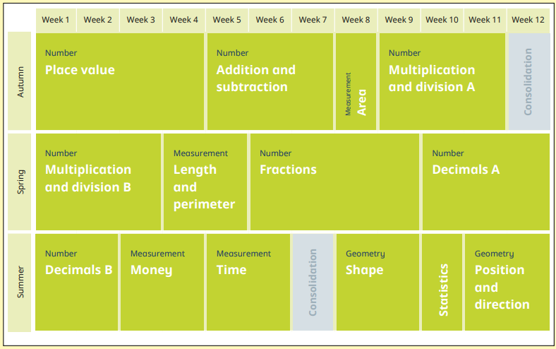

**YEAR FIVE**

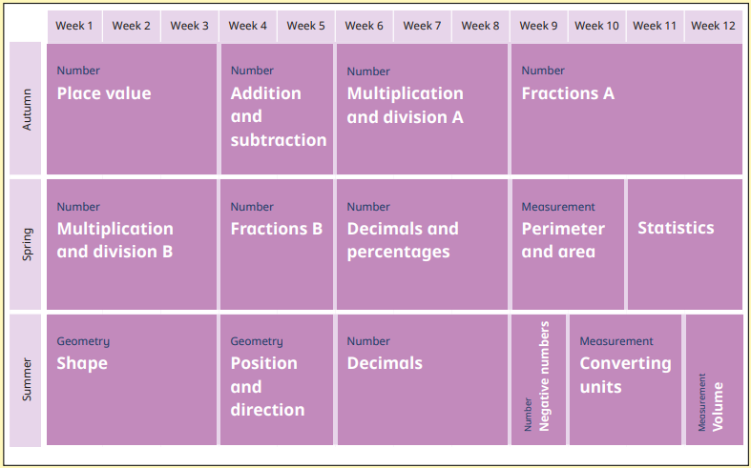

**YEAR SIX**

|  |  |  |  |  |  |  |  |  |  |  |  |  |  |
| --- | --- | --- | --- | --- | --- | --- | --- | --- | --- | --- | --- | --- | --- |
|  | Week 1 | Week 2 | Week 3 | Week 4 | Week 5 | Week 6 |  | Week 7 | Week 8 | Week 9 | Week 10 | Week 11 | Week 12 |
| Autumn Term | Number  **Place Value** | | Number  **Addition/Subtraction**  **Multiplication/Division** | | | Geometry  **Shape** |  | Geometry  **Shape** | Number  **Fractions**  **A** | | **Statistics** | | Measurement  **Area and Perimeter** |
| Spring Term | Number  **Decimals** | | Number  **Addition/Subtraction**  **Multiplication/Division** | | Number  **Ratio** | Number  **Algebra** |  | Geometry  **Position and Direction** | Number  **Fractions**  **B** | | Measurement  **Converting Units of Measure** | Number  **Fractions, Decimals and Percentages** | |
| Summer Term | Number  **Calculations** | Number  **Fractions**  **C** | | **SATs** | **Investigations and Problem Solving** | |  | **Investigations and Problem Solving** | | | | | |